**Song Dataset**

The first dataset is a subset of real data from the [Million Song Dataset](https://labrosa.ee.columbia.edu/millionsong/). Each file is in JSON format and contains metadata about a song and the artist of that song. The files are partitioned by the first three letters of each song's track ID. For example, here are filepaths to two files in this dataset.

song_data/A/B/C/TRABCEI128F424C983.json

song_data/A/A/B/TRAABJL12903CDCF1A.json

And below is an example of what a single song file, TRAABJL12903CDCF1A.json, looks like.

{"num_songs": 1, "artist_id": "ARJIE2Y1187B994AB7", "artist_latitude": null, "artist_longitude": null, "artist_location": "", "artist_name": "Line Renaud", "song_id": "SOUPIRU12A6D4FA1E1", "title": "Der Kleine Dompfaff", "duration": 152.92036, "year": 0}

**Log Dataset**

The second dataset consists of log files in JSON format generated by this [event simulator](https://github.com/Interana/eventsim) based on the songs in the dataset above. These simulate activity logs from a music streaming app based on specified configurations.

The log files in the dataset you'll be working with are partitioned by year and month. For example, here are filepaths to two files in this dataset.

log_data/2018/11/2018-11-12-events.json

log_data/2018/11/2018-11-13-events.json

And below is an example of what the data in a log file, 2018-11-12-events.json, looks like.

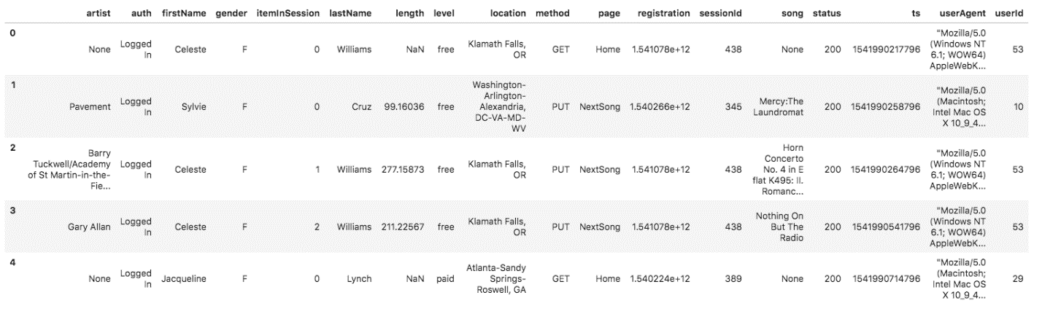

If you would like to look at the JSON data within log_data files, you will need to create a pandas dataframe to read the data. Remember to first import JSON and pandas libraries.

df = pd.read_json(filepath, lines=True)

For example, df = pd.read_json('data/log_data/2018/11/2018-11-01-events.json', lines=True) would read the data file 2018-11-01-events.json.

In case you need a refresher on JSON file formats, [here is a helpful video](https://www.youtube.com/watch?time_continue=1&v=hO2CayzZBoA).